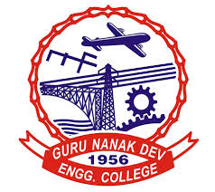

GURU NANAK DEV ENGINEERING COLLEGE, LUDHIANA-141006
[An Autonomous College under UGC Act, 1956 (under section 2(f) and 12 (B)]
Affiliated to Punjab Technical University, Jalandhar.

Department of Business Administration

M.B.A Admission Enquiry

-Contact Numbers-

Dr.Parampal Singh Assoc.Prof.&Head 9815903230
Dr.Amanjot K Gill Asstt.Prof. 9876156364
Dr.H.S. Dhall Asstt.Prof 9417992553
Dr. Navdeep Kaur Asstt.Prof. 9876343366
Prof.Amarpreet Kaur Asstt.Prof. 9877792179
Prof.Mandeep Kaur Khosa Asstt.Prof. 9464912297

